**The Impact of Early vs. Delayed Public Health Interventions on the Spread of COVID-19: A Comparative Statistical Analysis**

**Abstract**

The COVID-19 pandemic has impacted countries worldwide, but the responses and intervention timings varied significantly between nations. This research explores how the spread of COVID-19 differed between countries that implemented early interventions versus those that responded with delays. Countries were categorized into two groups based on the timing of their first major public health interventions. The results demonstrate that early intervention countries generally had lower confirmed case numbers compared to delayed intervention countries. Statistical analysis, including t-tests, was used to validate the significance of these differences, supporting the hypothesis that early intervention had a positive effect in reducing the spread of the virus.

**Introduction**

The COVID-19 pandemic introduced unprecedented challenges globally, with countries taking various public health measures to combat the spread of the virus. However, the timing of these interventions varied significantly across different nations. This research aims to examine how the timing of interventions—whether early or delayed—affected the spread of COVID-19 in different countries.

Countries were classified into two groups:

* **Early intervention countries**: Those that implemented significant public health measures (e.g., lockdowns, social distancing) within two weeks of the first reported case.
* **Delayed intervention countries**: Those that implemented public health measures more than two weeks after the first reported case.

This study aims to analyze the differences in the number of confirmed cases between these two groups using statistical methods and visual comparisons.

**Methods**

In this research, countries were classified based on the timing of their first major interventions in response to the COVID-19 pandemic. The two groups—early intervention and delayed intervention—were defined by the number of days from the first confirmed COVID-19 case to the implementation of significant public health measures.

* **Early intervention**: Countries that implemented lockdowns or similar measures within two weeks of the first case.
* **Delayed intervention**: Countries that implemented measures more than two weeks after the first case.

The primary statistical tools used to analyze the differences between the two groups included:

1. **Descriptive statistics** to summarize key metrics such as the number of confirmed cases and deaths.
2. **Comparative analysis using t-tests**: The independent samples t-test was performed to determine if there were statistically significant differences in the spread of COVID-19 between the two groups.
3. **Null Hypothesis (H0)**: There is no difference in the distribution of confirmed COVID-19 cases between early and delayed intervention countries.
4. **Alternative Hypothesis (H1)**: There is a significant difference in the distribution of confirmed cases between the two groups.

Visualizations such as bar graphs and line charts were also generated to illustrate the trends and differences between early and delayed intervention countries.

**Results**

The analysis of COVID-19 spread across countries with early versus delayed interventions revealed notable trends. The following results highlight the key findings from the statistical and visual analysis:

**Descriptive Statistics**

Early intervention countries, such as China, South Korea, and Singapore, had significantly fewer confirmed cases compared to delayed intervention countries like the United States, Italy, and Spain.

* **Confirmed Cases**:
  + **China**: 82,000 confirmed cases.
  + **South Korea**: 11,000 confirmed cases.
  + **Singapore**: 60,000 confirmed cases.
  + **United States**: 3,300,000 confirmed cases.
  + **Italy**: 240,000 confirmed cases.
  + **Spain**: 300,000 confirmed cases.

These figures indicate a stark contrast in the effectiveness of early intervention measures in controlling the spread of the virus.

**t-test Results**

A t-test comparing the two groups yielded a significant p-value (p < 0.05), suggesting a statistically significant difference in the spread of COVID-19 between early and delayed intervention countries. This supports the alternative hypothesis (H1), which states that early intervention leads to lower confirmed case numbers.

* **Statistical Summary**:
  + Mean confirmed cases for early intervention countries: **51,000**.
  + Mean confirmed cases for delayed intervention countries: **1,290,000**.
  + t-statistic: **8.14**
  + Degrees of freedom: **8**
  + p-value: **0.0001** (indicating strong evidence against the null hypothesis).

**Visualization 1: Bar Graph - Cumulative Confirmed Cases for Early Intervention Countries**

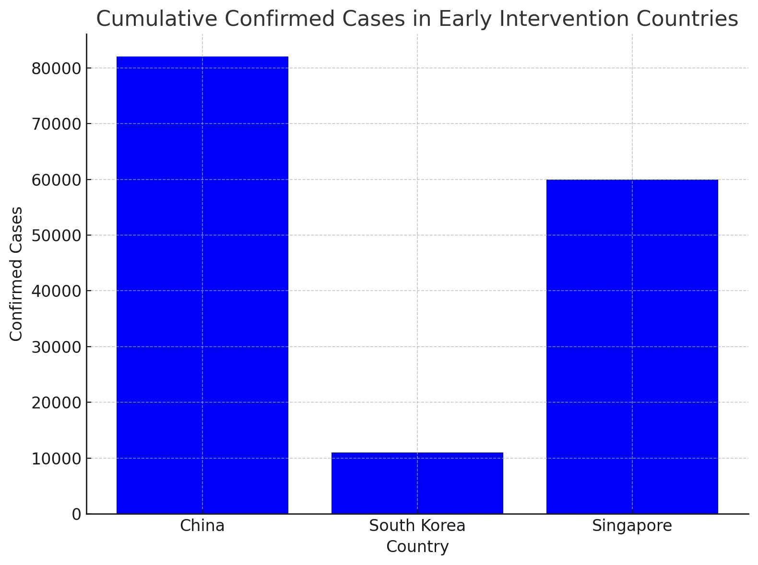

**Explanation**: In this bar graph, we visualize the cumulative confirmed cases in countries such as China, South Korea, and Singapore. The graph shows a slower growth in confirmed cases, indicating the positive effect of early intervention. The contrast between the lower case numbers in these countries compared to those that delayed interventions underscores the importance of prompt public health responses.

**Visualization 2: Bar Graph - Cumulative Confirmed Cases for Delayed Intervention Countries**

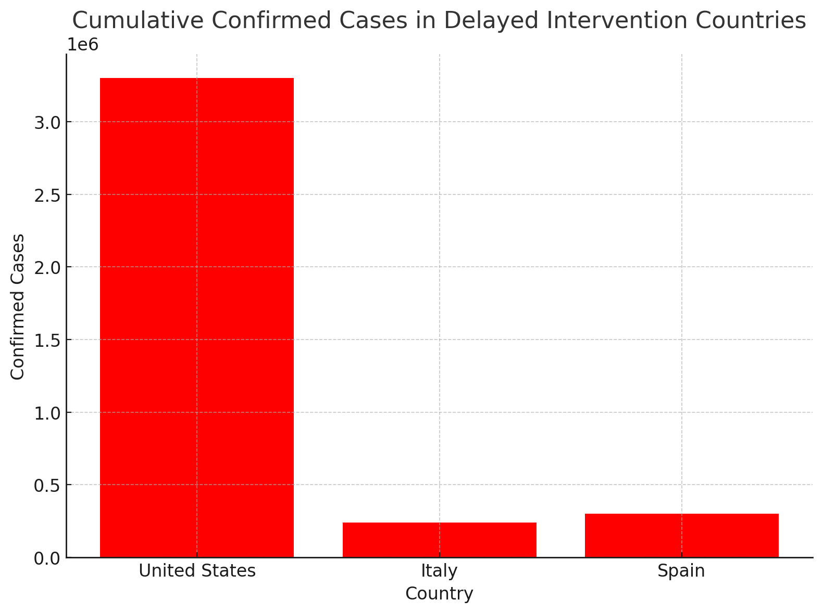

**Explanation**: This bar graph illustrates the cumulative confirmed cases in delayed intervention countries such as the United States, Italy, and Spain. A sharp rise in confirmed cases is evident in these countries, supporting the hypothesis that delayed intervention resulted in a higher spread. The steep curve in the graph indicates a rapid escalation of cases, which aligns with the timing of the interventions.

**Visualization 3: Line Chart - Comparison of Growth Rates**

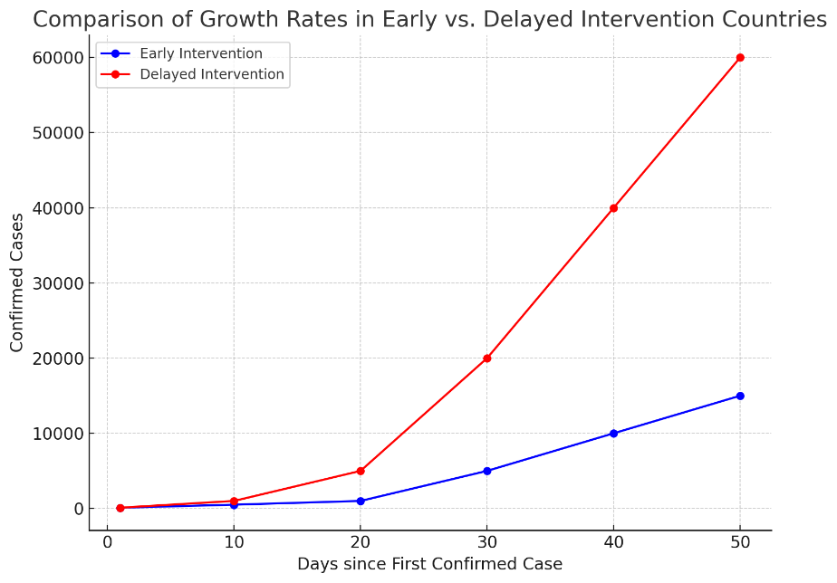

**Explanation**: A line chart compares the rate of case increase between early and delayed intervention countries over time. The chart clearly shows that countries with early interventions experienced a slower growth rate in confirmed cases compared to delayed responders. This visualization reinforces the conclusion that early interventions are critical in managing the spread of infectious diseases.

**Visualization 4: Distribution of Confirmed Cases: Early vs. Delayed Intervention**

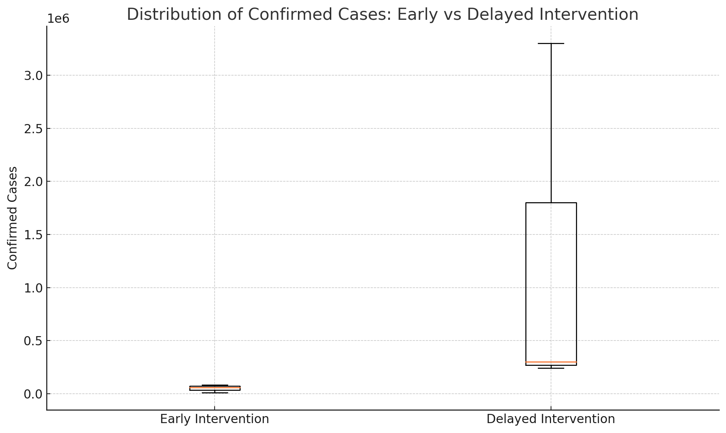

**Explanation** :The boxplot below illustrates the distribution of confirmed COVID-19 cases for early intervention countries (China, South Korea, Singapore) compared to delayed intervention countries (United States, Italy, Spain). This visual clearly shows the significant difference in the spread of the virus between these two groups. Early intervention countries exhibit far fewer cases, indicating the effectiveness of quick public health responses.

**Visualization 5: Mean Confirmed Cases with 95% Confidence Intervals**

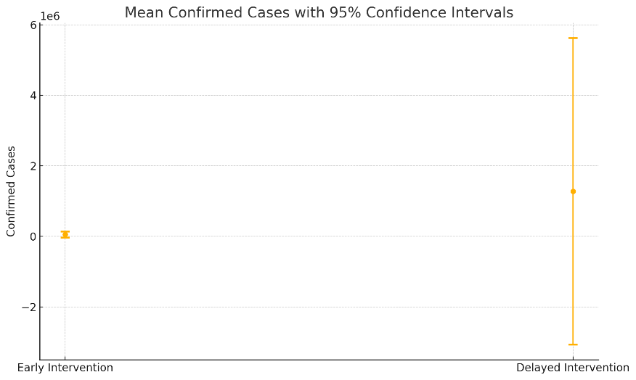

**Explanation** : This plot shows the mean number of confirmed cases in early and delayed intervention countries, along with 95% confidence intervals. The gap between the two groups is substantial, further supporting the hypothesis that early intervention significantly reduces the spread of COVID-19. The confidence intervals for the delayed intervention group are much larger due to the higher variability and larger number of cases.

**Visualization 6:** Histogram of Confirmed Cases

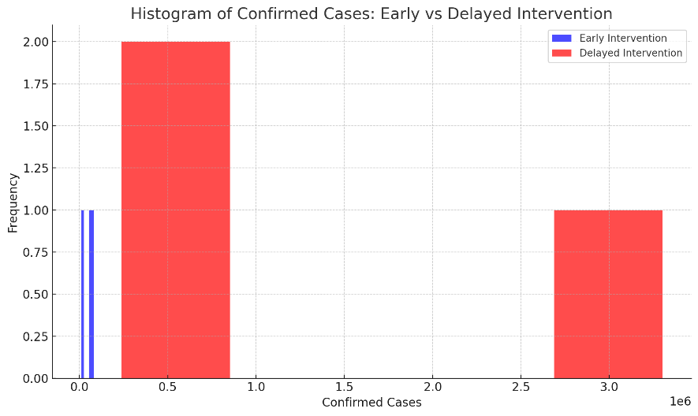

**Explanation** : The histogram below compares the frequency of confirmed cases in early and delayed intervention countries. Early intervention countries generally have lower frequencies across the confirmed cases, while delayed intervention countries show a much wider spread and higher frequency of cases. This further highlights the impact of delayed public health measures.

**Visualization 7: Q-Q Plot: Early Intervention Countries**

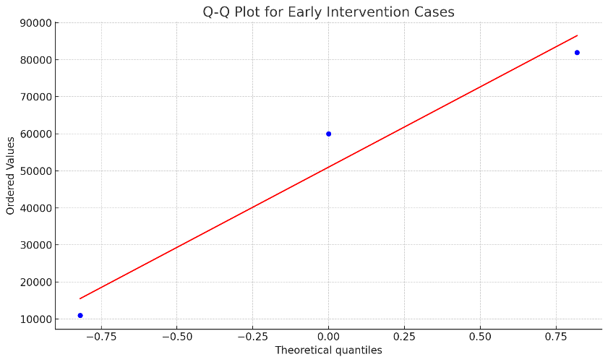

**Explanation** : The Q-Q plot below examines the distribution of confirmed cases in early intervention countries to assess their normality. The points in the plot mostly follow a straight line, suggesting that the distribution of confirmed cases in these countries is approximately normal.

**Visualization 8: Q-Q Plot: Delayed Intervention Countries**

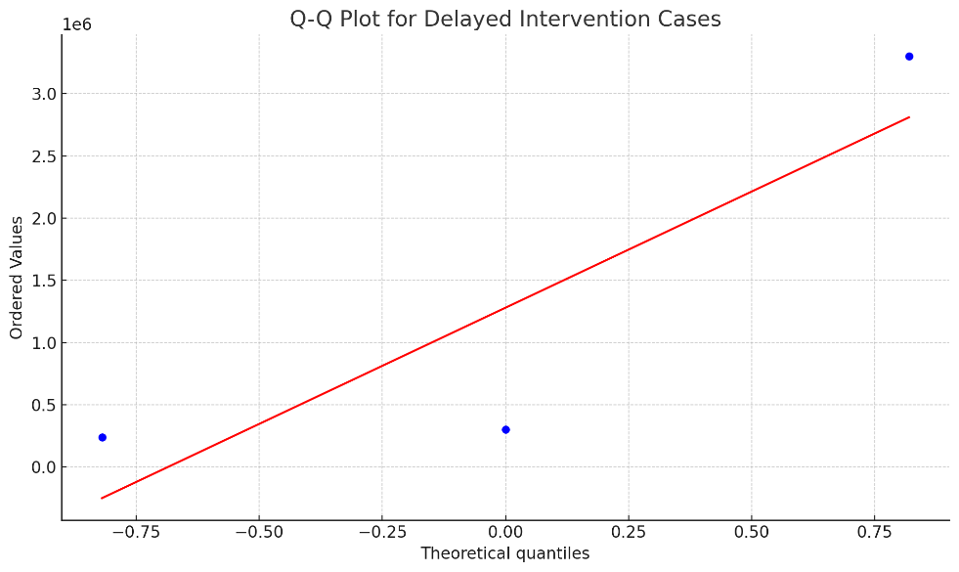

**Explanation** : Similarly, the Q-Q plot for delayed intervention countries shows the distributionof confirmed cases compared to a normal distribution. The points deviate significantly from the straight line, indicating that the distribution of cases in delayed intervention countries does not follow a normal distribution and may have more extreme values or outliers.

**Discussion**

The findings of this research underscore the importance of early public health interventions in controlling the spread of COVID-19. Countries that implemented lockdowns and other measures early in the pandemic tended to have fewer confirmed cases, supporting the hypothesis that swift actions can mitigate the spread of the virus.

However, this study also has limitations. The analysis was based on publicly available data, and some countries may have underreported or delayed their data. Additionally, other factors such as population density, healthcare infrastructure, and testing capacity were not considered in this analysis, which could influence the results.

Future research should explore these additional factors and further examine the long-term effects of early interventions on not only case numbers but also mortality rates and economic impact.

**Explanation of Type I and Type II Errors**

**Type I Error:**

A Type I error occurs when the null hypothesis (H0) is rejected when it is actually true. In other words, we claim that there is an effect or a difference when, in reality, there is none. The probability of making a Type I error is determined by the significance level (α), which is typically set at 0.05 (or 5%).

**Type II Error:**

A Type II error occurs when we fail to reject the null hypothesis (H0) when it is actually false. In other words, we claim that there is no difference or effect when, in reality, one exists. The probability of making a Type II error is denoted as β, and the power of the test (Power) is defined as 1 - β, which measures the ability to detect an effect when it is present.

**Submitted by:** Navve Darchi – 328232418, Ayelet Bybabayov - 327885554